Project Documentation
Plant Health Monitoring System
Cantor Lavinia-Denisa

1. Introduction

1.1 Functional use and purpose
The purpose of this project is to design and implement an IoT-based system capable of monitoring the health of a plant by continuously measuring key environmental parameters. Proper plant growth depends on both soil and atmospheric conditions, therefore monitoring these parameters allows better control of irrigation and environmental factors.
The main objective of the project is to measure the soil moisture level in order to determine whether the plant requires watering. In addition to this, the system measures air temperature and air humidity, which have a significant impact on plant development. Another important goal is the wireless transmission of the collected data to a cloud platform, enabling remote monitoring and data visualization.

1.2 Tools and technologies used
The hardware architecture of the system is based on the ESP32 microcontroller, which acts as the central processing unit. The ESP32 reads data from the connected sensors, processes the information, and transmits it via Wi-Fi.
A capacitive soil moisture sensor is used to measure the moisture content of the soil, offering improved durability and accuracy compared to resistive sensors.
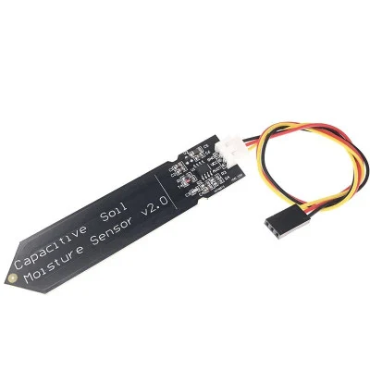
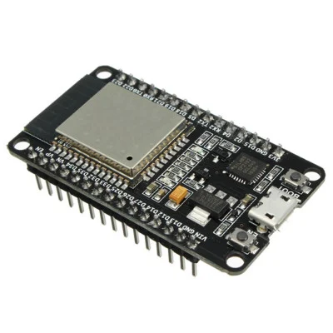

For monitoring atmospheric conditions, a DHT11 sensor is employed to measure both air temperature and air humidity.
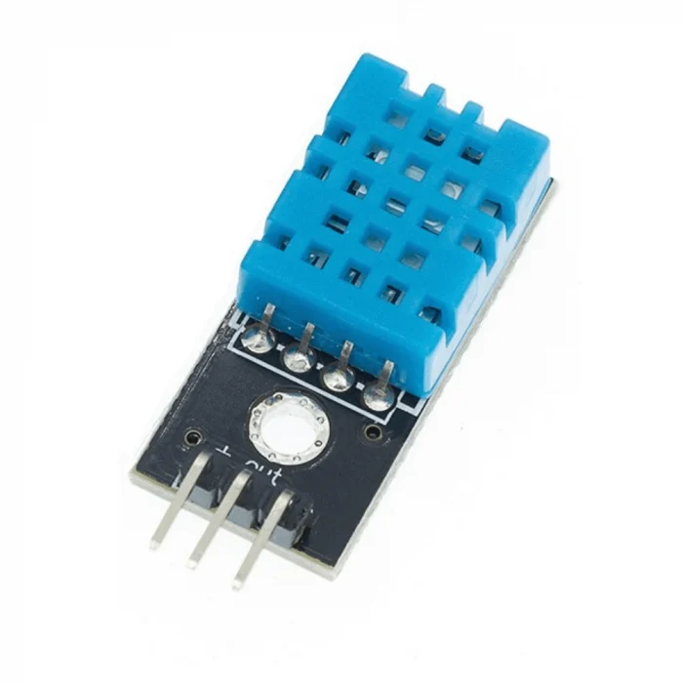

On the software side, several tools and platforms were used to develop the system.
- The Arduino IDE was used to write, compile, and upload the firmware to the ESP32 microcontroller. This firmware handles sensor data acquisition, Wi-Fi connectivity, and communication with the cloud platform.
- Python was used to develop a graphical user interface that allows the user to visualize the sensor data in a clear and intuitive way. The interface retrieves data from the cloud and displays the current environmental conditions of the plant.
- ThingSpeak was used as the cloud-based IoT platform to receive, store, and visualize the sensor data transmitted by the ESP32, as well as to enable communication between the microcontroller and the Python interface.
2. Implementation steps
The implementation of the system begins with connecting the capacitive soil moisture sensor and the DHT11 temperature and humidity sensor to the ESP32 microcontroller.
- The capacitive soil moisture sensor is connected to an analog input of the ESP32, with its signal output connected to GPIO 34, while the power supply pins are connected to 3.3 V and GND.
- The DHT11 sensor is connected to a digital input pin, with its data line connected to GPIO 15 (D15), and is powered using the 3.3 V and GND pins of the ESP32.

After completing the hardware connections, the ESP32 is programmed using the Arduino IDE. The firmware is designed to periodically read the analog value from the soil moisture sensor and the digital temperature and humidity values from the DHT11 sensor. The microcontroller processes the collected data and establishes a Wi-Fi connection to the local network.
#include "DHT.h"
#include <HTTPClient.h>
const char* ssid = "DenisaiPhone";
const char* password = "Lavinia123";

String writeAPIKey = "1A0MEV2M0C3EEGL6";

#define DHTTYPE DHT11

DHT dht(DHTPIN, DHTTYPE);

#define SOIL_PIN 34

int soilWet = 800;
int soilDry = 3500;

void setup() {

Serial.begin(115200);

delay(2000);
Serial.println("Conectare la WiFi...");

WiFi.begin(ssid, password);

while (WiFi.status() != WL_CONNECTED) {

// pauza 0.5 sec
delay(500);

Serial.print(".");
}

Serial.println("\nConectat la WiFi!");
dht.begin();

pinMode(SOIL_PIN, INPUT);
}

void loop() {
float humidity = dht.readHumidity();
float temperature = dht.readTemperature();
int soilRaw = analogRead(SOIL_PIN);
if (isnan(humidity) || isnan(temperature)) {

Serial.println("Eroare citire DHT11!");

delay(2000);

return;
}
int soilPercent = map(soilRaw, soilDry, soilWet, 0, 100);
soilPercent = constrain(soilPercent, 0, 100);

Serial.println("----- Date Senzori -----");

Serial.print("Umiditate aer: ");
Serial.println(humidity);

Serial.print("Temperatura aer: ");
Serial.println(temperature);

Serial.print("Umiditate sol (%): ");
Serial.println(soilPercent);

Serial.print("RAW sol: ");
Serial.println(soilRaw);

if (WiFi.status() == WL_CONNECTED) {
HTTPClient http;

String url = "http://api.thingspeak.com/update?api_key=" + writeAPIKey +
"&field1=" + String(soilPercent) +
"&field2=" + String(temperature) +
"&field3=" + String(humidity);
http.begin(url);
int httpCode = http.GET();

http.end();

Serial.print("ThingSpeak raspuns: ");erefrewwefw2fef3fuyerwuhfergufccgyuyyhh
Serial.println(httpCode);
}
delay(20000);
}

Once connected to the network, the ESP32 transmits the measured sensor data to the ThingSpeak cloud platform using HTTP requests and ThingSpeak Write API Key, which authorizes the ESP32 to upload data to the specific ThingSpeak channel. The sensor data is updated at 20-second intervals, in accordance with the platform’s data upload limitations.
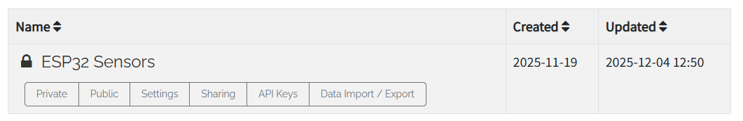
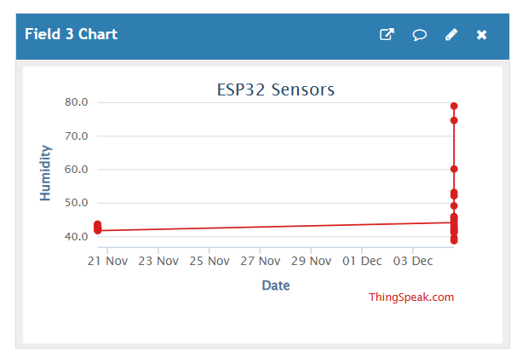
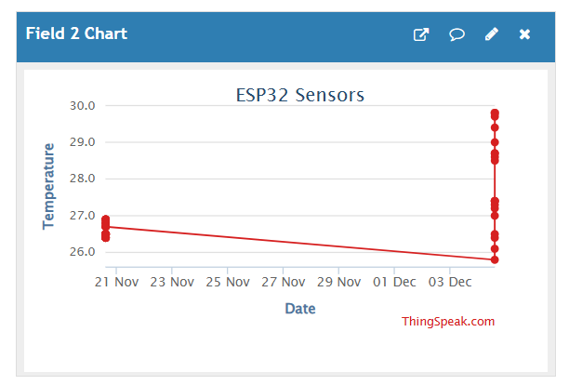
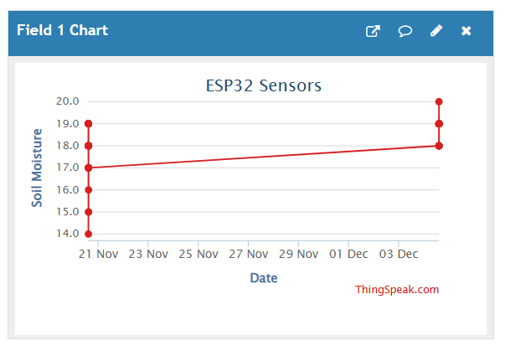

In parallel, a Python-based graphical user interface is implemented to retrieve the stored data from ThingSpeak using the Read API Key. The interface processes the received information and displays the soil moisture level, air temperature, and air humidity values in real time, allowing continuous monitoring of the plant’s environment.
import requests
import tkinter as tk
from tkinter import ttk
from PIL import Image, ImageTk
import matplotlib
import matplotlib.pyplot as plt
from matplotlib.backends.backend_tkagg import FigureCanvasTkAgg # Embeds matplotlib charts inside Tkinter
matplotlib.use("TkAgg") # tkinter afiseze graficele
# matplotlib - biblioteca desenează grafice
# -----------------------------------------------------
# THINGSPEAK CONFIGURATION
# -----------------------------------------------------
CHANNEL_ID = 3171926 # ThingSpeak channel ID
READ_API_KEY = "N1DKFNFYZBE7VORT" # API key allowing read-only access
URL = f"https://api.thingspeak.com/channels/{CHANNEL_ID}/feeds.json?api_key={READ_API_KEY}&results=20"
# URL to request the last 20 measurements
# -----------------------------------------------------
# FUNCTION TO READ DATA FROM THINGSPEAK
# -----------------------------------------------------
def get_data():
try:
r = requests.get(URL) # Send HTTP GET request
data = r.json()["feeds"] # Extract "feeds" list from JSON response
# Create lists of numeric values (skip entries that are empty)
soil = [float(x["field1"]) for x in data if x["field1"]]
temp = [float(x["field2"]) for x in data if x["field2"]]
hum = [float(x["field3"]) for x in data if x["field3"]]
return soil, temp, hum
except:
# If any error occurs, return empty lists
return [], [], []
# -----------------------------------------------------
# Function to UPDATE THE DASHBOARD UI
# -----------------------------------------------------
def update_dashboard():
soil, temp, hum = get_data() # Read fresh data
if len(soil) == 0: # If no data is available
root.after(5000, update_dashboard)
# root.after(ms, function) → calls update_dashboard function after 5000 milliseconds
return
# Extract the last measurement from each list
latest_soil = soil[-1]
latest_temp = temp[-1]
latest_hum = hum[-1]
# Update the number labels in the boxes
soil_value.config(text=f"{latest_soil:.1f}")
temp_value.config(text=f"{latest_temp:.1f}")
hum_value.config(text=f"{latest_hum:.1f}")
# -------------------------------------------------
# Change plant image + status based on soil moisture
# -------------------------------------------------
if latest_soil < 30: #updates labels
plant_label.config(image=sad_photo) # Set sad plant image, create the variables
plant_label.image = sad_photo # Keep reference so Tkinter doesn’t delete it
status_label.config(
text="💧 Water needed!",
bg="#FFB6C1"
)
else:
plant_label.config(image=happy_photo)
plant_label.image = happy_photo
status_label.config(
text="The plant is okay. 🍃",
bg="#CCFFE5"
)
# -------------------------------------------------
# Update the matplotlib chart
# -------------------------------------------------
ax.clear() # Clear previous plot
# define the lines for the plot
ax.plot(soil, label="Soil", linewidth=3)
ax.plot(temp, label="Temp", linewidth=3)
ax.plot(hum, label="Humidity", linewidth=3)
ax.legend()
ax.set_ylim(0, 100) # Set Y-axis limits
ax.set_title("Last 20 Measurements") # Title of the chart
canvas.draw() # draw the chart in the Tkinter window
# Call this function again after 5 seconds → continuous updating
root.after(5000, update_dashboard)
# -----------------------------------------------------
# GUI WINDOW
# -----------------------------------------------------
root = tk.Tk() # Create the main window; tk.Tk is the main class from Tkinter
root.title("Plant GUI 🌸") # Window title
root.geometry("950x700") # Window size (width x height)
root.config(bg="#FFEFF6") # Window background color
# -----------------------------------------------------
# LOAD PLANT IMAGES
# -----------------------------------------------------
happy_img = Image.open("plant_happy.png").resize((220, 220)) # Resize image to fit the UI
happy_photo = ImageTk.PhotoImage(happy_img) # Convert image to Tkinter format
sad_img = Image.open("plant_sad.png").resize((220, 220))
sad_photo = ImageTk.PhotoImage(sad_img)
# -----------------------------------------------------
# PAGE TITLE
# -----------------------------------------------------
title = tk.Label(
root,
text="🌸 Plant Monitor 🌸",
font=("Comic Sans MS", 32, "bold"),
bg="#FFEFF6",
fg="#FF69B4"
)
title.pack(pady=10)
# pady = vertical padding (space above/below the widget)
# -----------------------------------------------------
# PLANT IMAGE DISPLAY
# -----------------------------------------------------
plant_label = tk.Label(root, image=happy_photo, bg="#FFEFF6")
plant_label.pack(pady=5)
# -----------------------------------------------------
# STATUS BANNER
# -----------------------------------------------------
status_label = tk.Label( # creates status_label
root,
text="",
font=("Comic Sans MS", 26, "bold"),
bg="#CCFFE5",
fg="#FF1493",
width=20 # Width in text units, not pixels
)
status_label.pack(pady=10)
# -----------------------------------------------------
# VALUE BOXES (Soil, Temperature, Humidity)
# -----------------------------------------------------
frame = tk.Frame(root, bg="#FFEFF6")
frame.pack(pady=20)
# pady again = vertical space around the frame
# Function that creates a pink box with a title + numeric value
def create_box(parent, text):
box = tk.Frame(
parent,
bg="#FDE4EC",
highlightbackground="#F5B7C5", # Border color
highlightthickness=2, # Border thickness in pixels
width=300, # Fixed width of the box
height=120 # Fixed height
)
box.pack_propagate(False)
# pack_propagate(False) prevents Tkinter from resizing the box to fit its contents
label = tk.Label(
box,
text=text,
font=("Comic Sans MS", 18, "bold"),
bg="#FDE4EC",
fg="#C71585"
)
label.pack() # display text in box
value = tk.Label(
box,
text="--",
font=("Comic Sans MS", 32, "bold"),
bg="#FDE4EC",
fg="#FF69B4"
)
value.pack()
return box, value
# Create the 3 measurement boxes using grid layout
soil_box, soil_value = create_box(frame, "Soil Moisture (%)")
soil_box.grid(row=0, column=0, padx=15)
# grid(row, column) = position inside a grid
# padx = horizontal padding (space left & right)
temp_box, temp_value = create_box(frame, "Air Temperature (°C)")
temp_box.grid(row=0, column=1, padx=15)
hum_box, hum_value = create_box(frame, "Humidity (%)")
hum_box.grid(row=0, column=2, padx=15)
# -----------------------------------------------------
# MATPLOTLIB CHART AREA
# -----------------------------------------------------
fig, ax = plt.subplots(figsize=(8, 3), dpi=100) # Create the figure object
canvas = FigureCanvasTkAgg(fig, master=root) # adaptor intre matplotlib si tkinter
# master=root - place the widget inside the main window called root
canvas.get_tk_widget().pack() # Add the plot widget to the window
# -----------------------------------------------------
# START UPDATING THE DASHBOARD
# -----------------------------------------------------
update_dashboard() # Initial call
root.mainloop() # Tkinter event loop (keeps the window open)

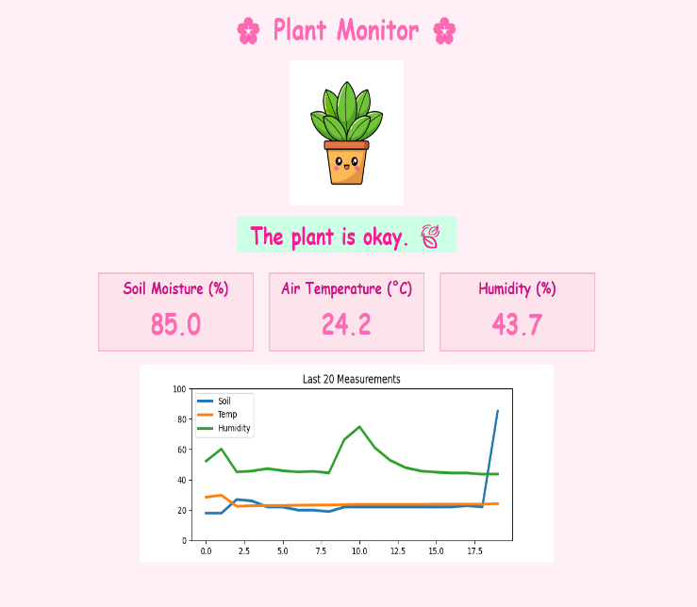
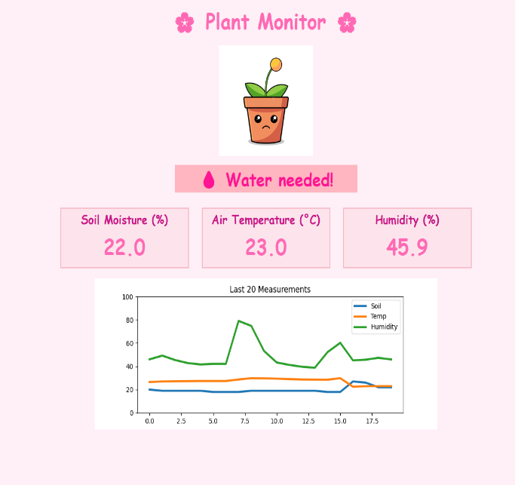
- The interface also provides a visual indication of the plant status and real-time graphical representation of the measured parameters. The plant status is determined based on soil moisture. If the soil moisture is below 30%, the system indicates that watering is required. If the value is above 30%, the plant is considered to be in normal condition.

3. Measurement results obtained
Serial Monitor
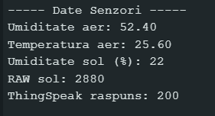
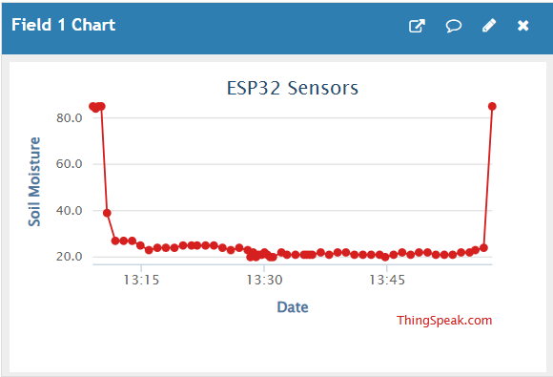
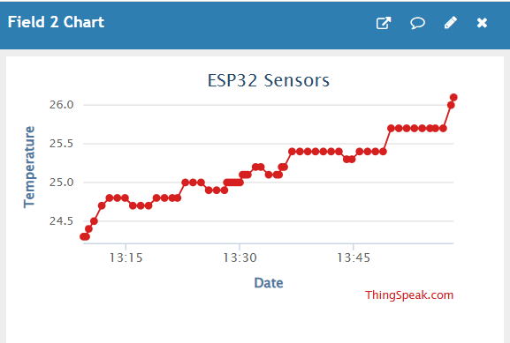
ThingSpeak

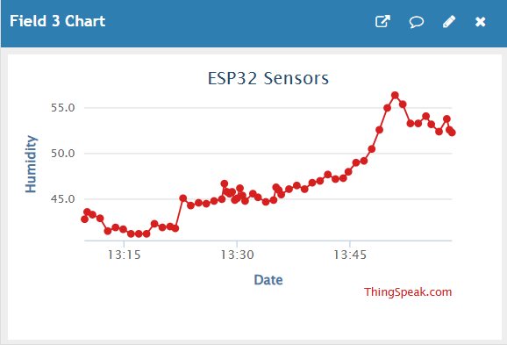

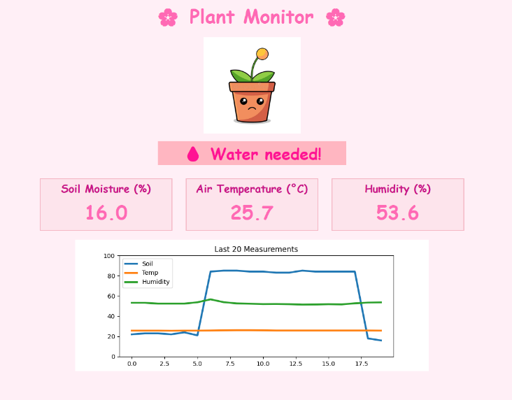
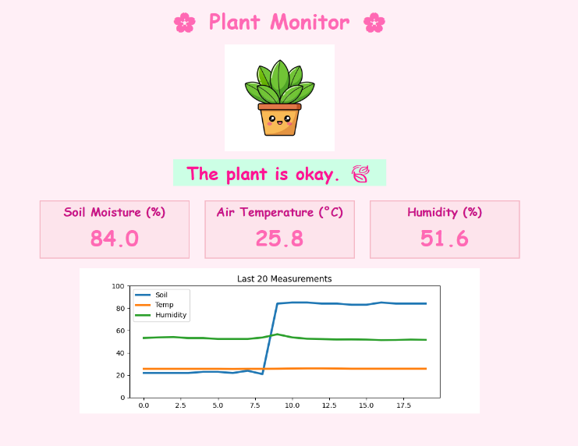
Python interface

